Week 3

I T 3 - Demonstrate searching data in a program:

A function that searches data (the countVisitors method):

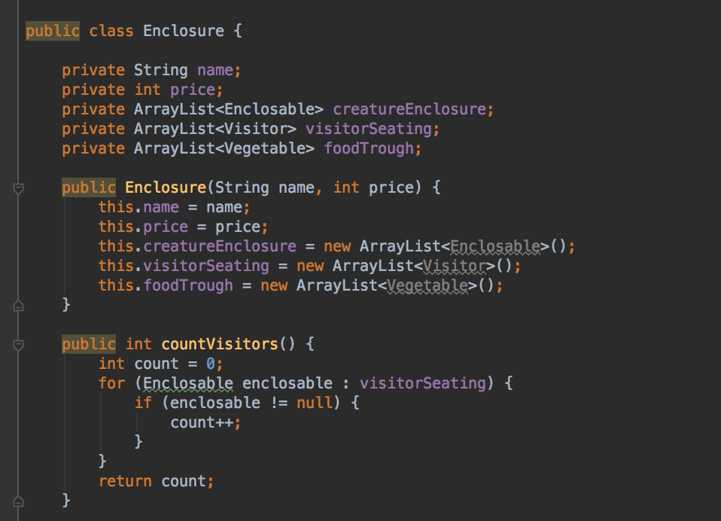

The result of this method is 0 as there has not yet been anything added to the empty arraylist.